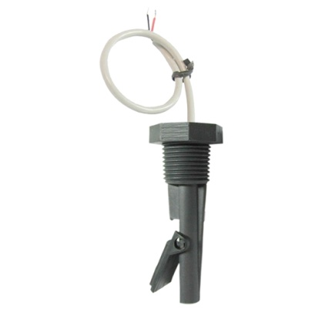

**Types R1Y and R1E**

**Paddle flow switches, reed switch contact, 1/2” male thread, extended paddle arm**

Main uses: Cost effective simple flow switch developed for swimming pool application. For water flow detection on vertical dia. 63 mm water pipes, upstream flow.

Main housing material: Polypropylene, resistant to ozone and water disinfection products, usable with potable water.

Electrical rating: Max 1A, Max 70W, Max 250V, resistive load.

Electric contact type: Normally close, open by flow rise.